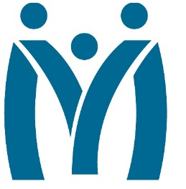

Metropolitan Human Services District
Board of Directors Meeting
March 2, 2018
12:30pm
Algiers Behavioral Health Clinic
3100 General DeGaulle Drive, New Orleans, LA 70014

MHSD fulfills its statutory role as the planning body for the behavioral health, addiction and intellectual/developmental disability services for the residents of Orleans, Plaquemines and St. Bernard Parishes by ensuring that eligible residents in these parishes have access to person centered and recovery focused supports designed to optimize their role in the community.
Agenda

- Call to Order

- Attendance

- Approval of the January Minutes

- Monitoring Reports
  - Review of the New Ends Policy

- Decision Information
  - Resolution – Gambling Awareness Month

- Consent Agenda

- Self-evaluation

- Adjourn

